* Access <https://console.cloud.google.com/> and register an account, this should be simple if you are using a Gmail account.  
  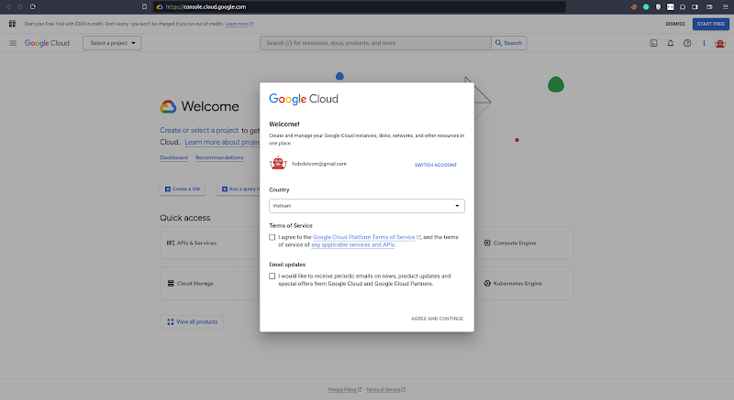
* Click the 2 checkboxes **Terms of Service** and **Email updates**, then hit **AGREE AND CONTINUE  
  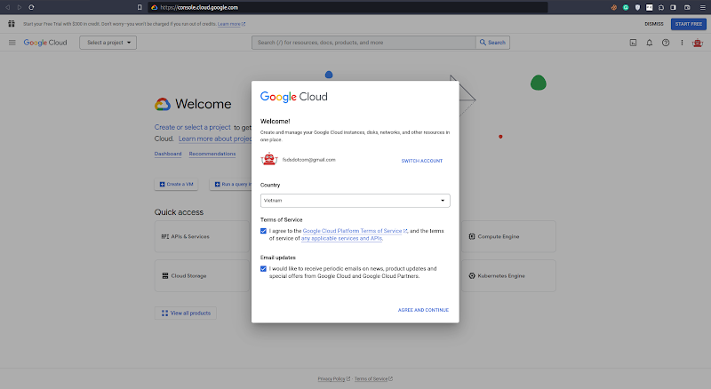**
* Click **Create a VM  
  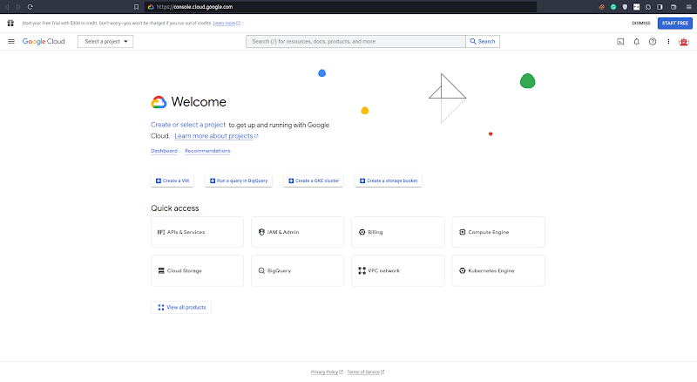**
* Hit **CREATE PROJECT  
  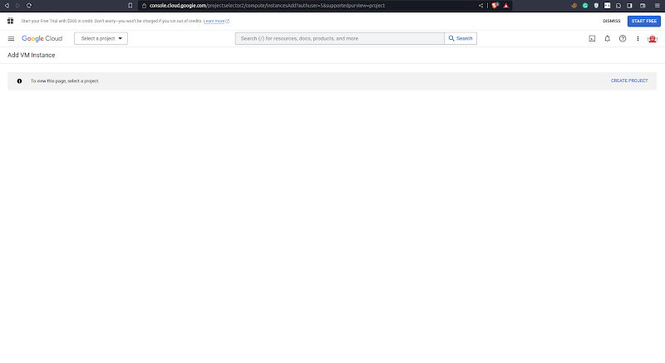**
* Fill **Project name** (for example, MLE course), and hit **Create  
  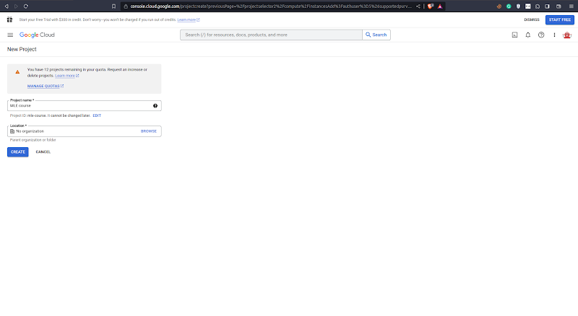￼**
* Click **CREATE BILLING ACCOUNT  
  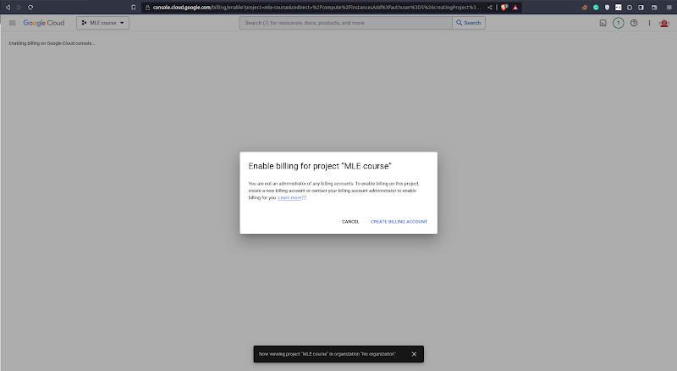**
* Under **What best describes your organization or needs?**, select **Startup** (or whatever),click the check box under **Terms of Service,** and hit **Continue.  
    
  Note:** In this case, I have a work email, so I fill my work email under **Apply for additional credits (optional)** to get an additional $100 in Free Trial credits. If you don't have it, just leave it empty.  
  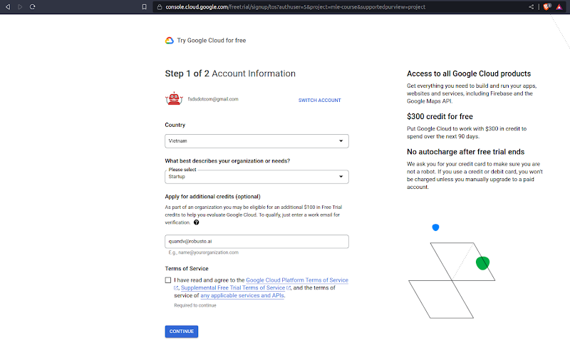
* Fill in your payment information and hit **START MY FREE TRIAL  
  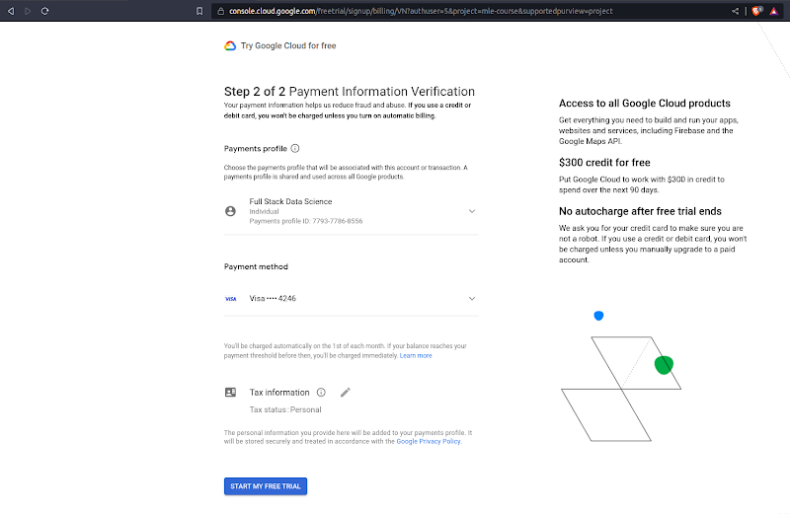**
* Cool! We now have access to our free trial, simply click the **CLOSE** button to close the **Welcome!** popup.  
  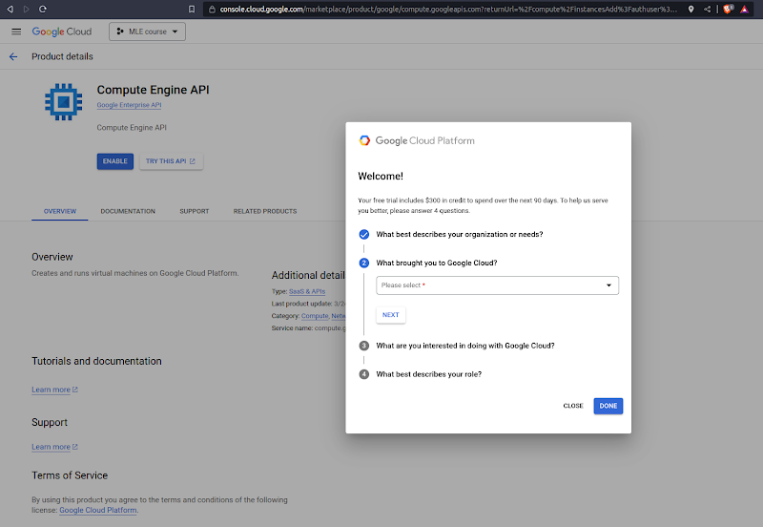
* Hit the blue **ENABLE** button  
  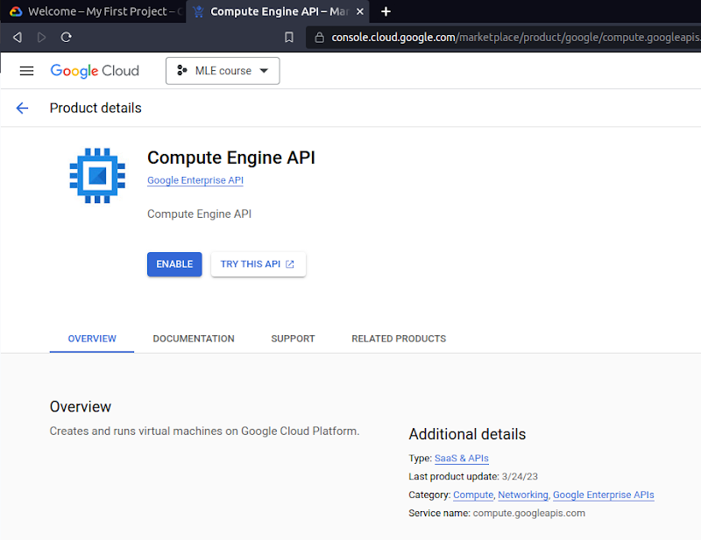  
  We can see Google is helping us to enable it in the Notifications (click the bell button). Please wait for a while.  
  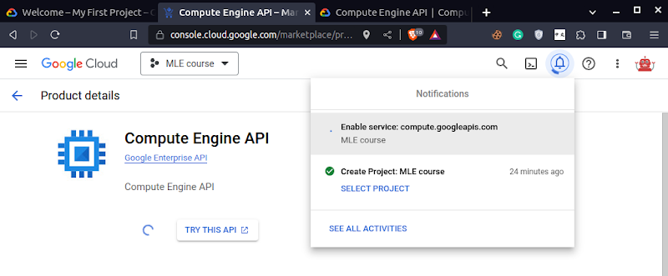
* Now, you can see the page **Create an instance** similar to this.  
  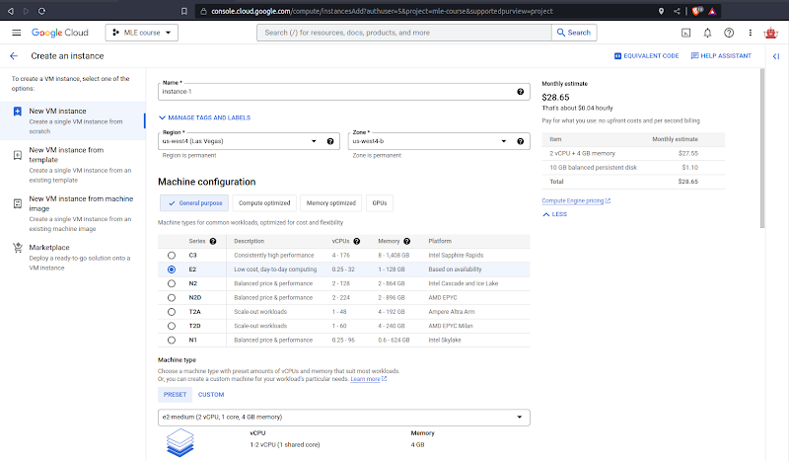
* You can play around with different Series under Machine configuration, for example, select N2D, which is a popular choice and you can see the **Monthly estimate** has been updated to $56.67 at the top right corner. **If you use this VM for development (instead of using a local machine), I suggest using an E2 machine (e.g. e2-standard-8).**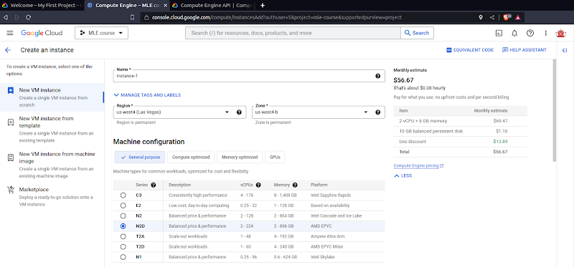

For now, let’s use Series E2!

* Change the Machine type to **e2-micro**, which has only 1 core and 1 GB of memory so we can not do much with it, but don’t worry, we can upgrade it later.  
  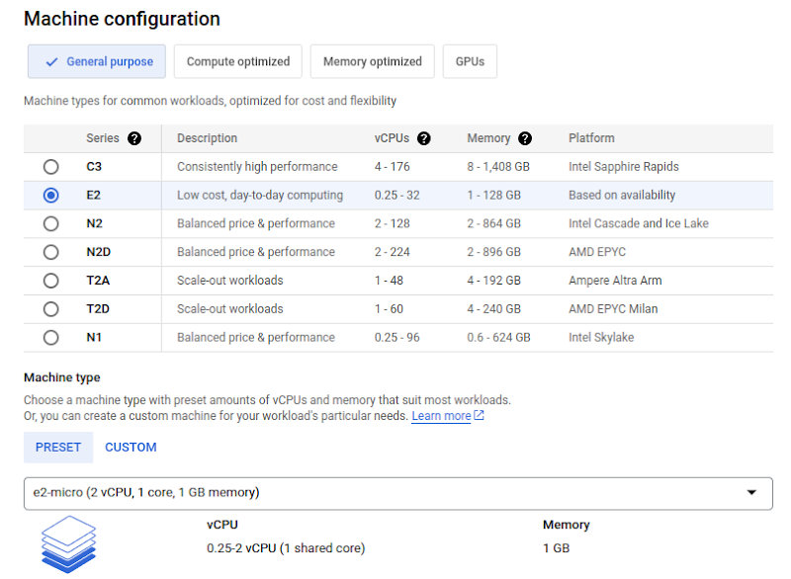

and hit **CREATE** at the bottom  
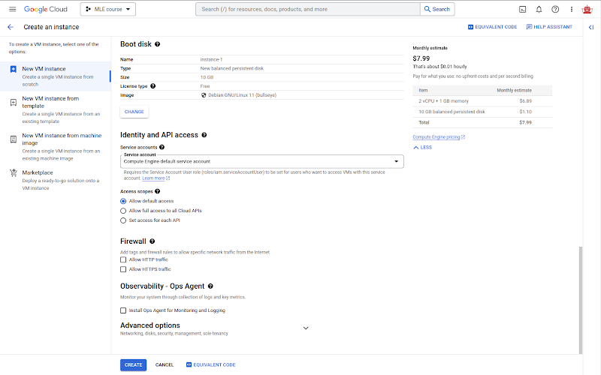  
**Hint:** If you click the button **EQUIVALENT CODE** you will see a tab open on the right-hand side with 3 tabs: COMMAND LINE, REST, TERRAFORM. These 3 are the other 3 different ways to create the instance (or VM). But ignore them for now.  
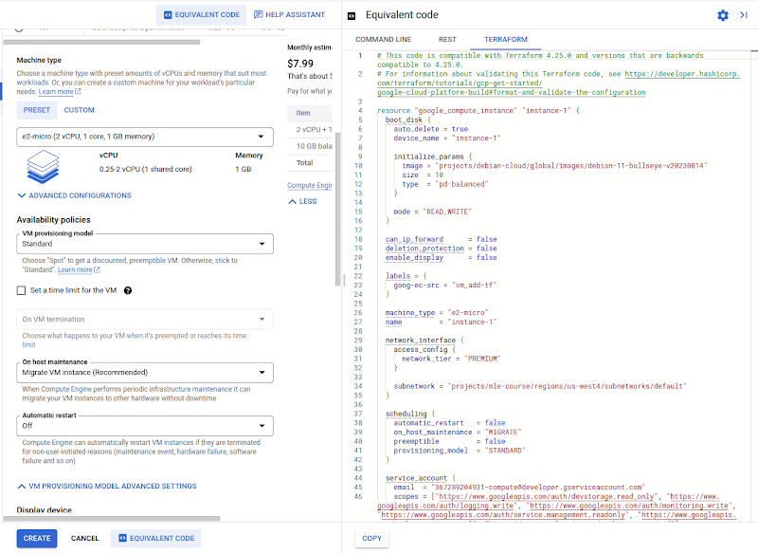

* After hitting the blue **CREATE** button and waiting for a while, you will see that **instance-1** has been created with the green tick. So far so good =)).  
  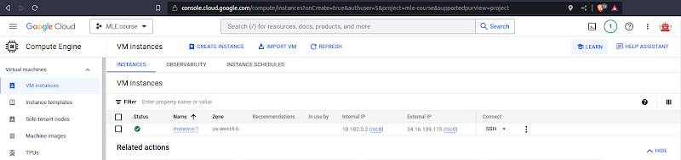
* Now, let’s find a way to access this instance via SSH.  
  First, check if we can connect to the External IP via port 22 by using telnet on your local terminal. You can see I use my External IP 34.16.139.115, but you will be different, please **be careful**. OK, connected!  
  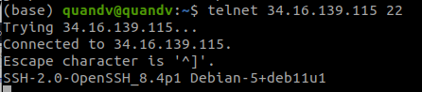Select
* Select **Metadata** under **Settings  
  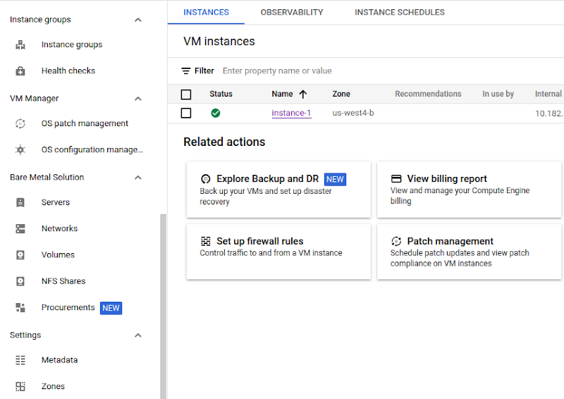**
* Select the tab **SSH KEYS** and click the button **+ ADD ITEM** (or **ADD SSH KEY** if you don’t see the **+ ADD ITEM button**)
* Generate your SSH key  
  Open your local terminal, type `ssh-keygen` and type Enter to die until **Overwrite (y/n)** type **y**, then continue to Enter to die until the randomart image appears.  
  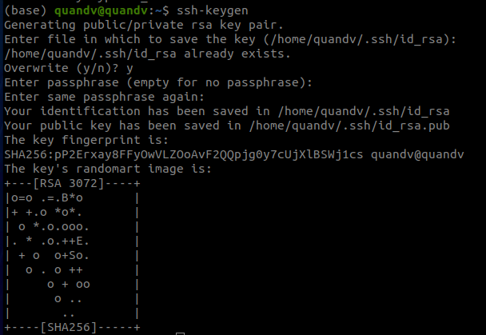
* Copy the content of your file `~/.ssh/id_rsa.pub` to GCP and press the blue button **SAVE** at the bottom of the page  
  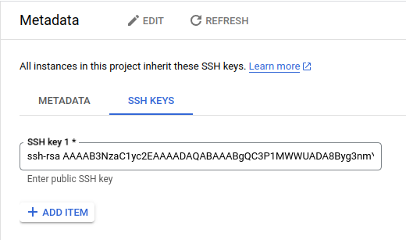

**Note:** To see the content of the file`~/.ssh/id_rsa.pub`, use the cat command  
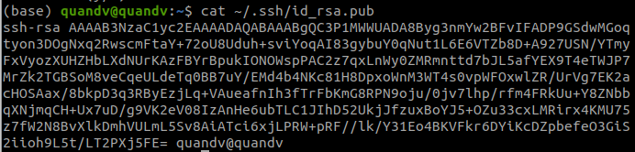

* Access your instance using the command `ssh -i ~/.ssh/id_rsa your_username@your_external_ip` as below  
  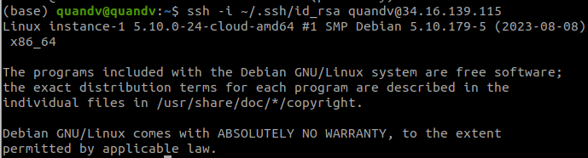

**Note:** To get the username, click the **SSH KEYS** tab again  
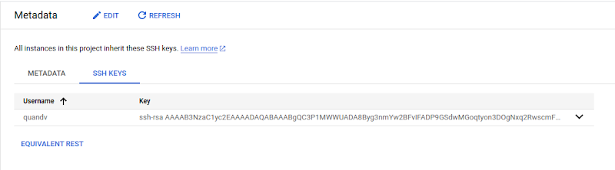

* Enjoy your new machine!  
  **Note:** If you want to have a UI instead of a terminal only, please follow this tutorial.  
  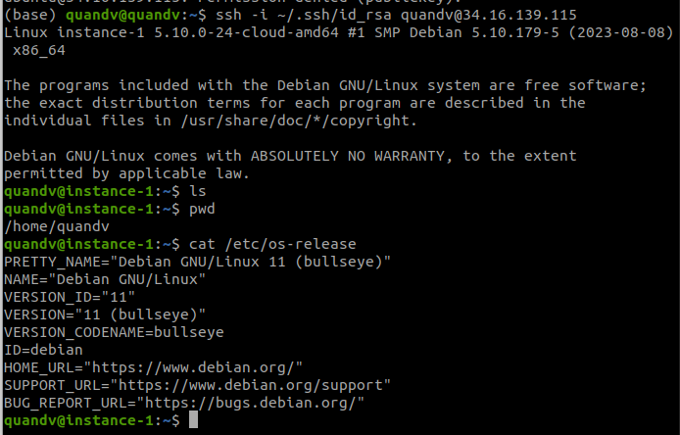
* Delete your machine by navigating to the **VM instances** tab, then clicking the 3 dots next to **SSH** and clicking **Delete.  
  